PIZZA SALES SQL QUERIES
- KPI’s
- Total Revenue:
SELECT SUM(total_price) AS Total_Revenue from [pizza_sales (1)]
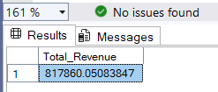

- Average Order Value:
SELECT SUM(total_price) / COUNT(DISTINCT order_id) AS Avg_order_value from [pizza_sales (1)]

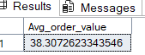

- Total Pizza Sold:
SELECT SUM(quantity) AS Total_Pizza_sold from [pizza_sales (1)]
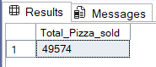

- Total Orders:
SELECT COUNT(DISTINCT order_id) AS Total_Orders from [pizza_sales (1)]
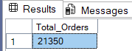

- Average Pizzas Per Order:
SELECT CAST(CAST(SUM(quantity) AS DECIMAL(10,2))/
CAST(COUNT(DISTINCT order_id) AS DECIMAL (10,2)) AS DECIMAL(10,2)) AS Avg_Pizzas_Per_Order from [pizza_sales (1)]
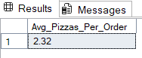

- DAILY TREND FOR TOTAL ORDERS:
SELECT DATENAME(DW, order_date) as order_day, COUNT(DISTINCT order_id) AS Total_orders
from [pizza_sales (1)]
GROUP BY DATENAME(DW, order_date)
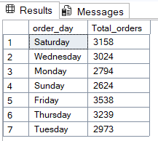
- MONTHLY TREND FOR ORDERS:
SELECT DATENAME(MONTH, order_date) AS Month_Name, COUNT(DISTINCT order_id) AS Total_Orders
from [pizza_sales (1)]
GROUP BY DATENAME(MONTH, order_date)
ORDER BY Total_Orders DESC
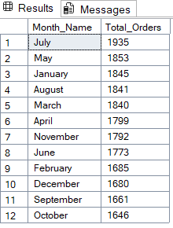
- % OF SALES BY PIZZA CATEGORY:
SELECT pizza_category, SUM(total_price) as Total_Sales, SUM(total_price) * 100 /
(SELECT SUM(total_price) from [pizza_sales (1)] WHERE MONTH(order_date) = 1) AS PCT
from [pizza_sales (1)]
WHERE MONTH(order_date) = 1
GROUP BY pizza_category
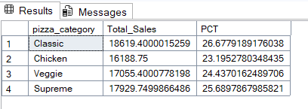

- % OF SALES BY PIZZA SIZE:
SELECT pizza_size, CAST(SUM(total_price) AS DECIMAL (10,2)) as Total_Sales, CAST(SUM(total_price) * 100 /
(SELECT SUM(total_price) from [pizza_sales (1)] WHERE DATEPART(quarter, order_date)=1) AS DECIMAL(10,2)) AS PCT
from [pizza_sales (1)]
WHERE DATEPART(quarter, order_date)=1
GROUP BY pizza_size
ORDER BY PCT DESC
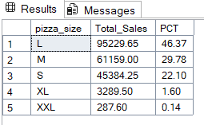
- TOTAL PIZZAS SOLD BY PIZZA CATEGORY:
SELECT pizza_category, SUM(quantity) as Total_Quantity_Sold
FROM pizza_sales
WHERE MONTH(order_date) = 2
GROUP BY pizza_category
ORDER BY Total_Quantity_Sold DESC
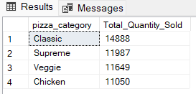
- TOP 5 PIZZAS BY REVENUE:
SELECT TOP 5 pizza_name, SUM(total_price) AS Total_Revenue
FROM [pizza_sales (1)]
GROUP BY pizza_name
ORDER BY Total_Revenue DESC
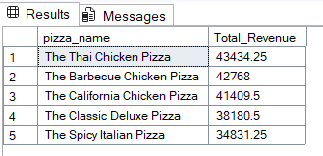
- BOTTOM 5 PIZZAS BY REVENUE:
SELECT TOP 5 pizza_name, SUM(total_price) AS Total_Revenue FROM[pizza_sales (1)]
GROUP BY pizza_name
ORDER BY Total_Revenue ASC
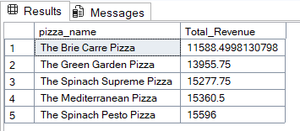
- TOP 5 PIZZAS BY QUANTITY:
SELECT TOP 5 pizza_name, SUM(quantity) AS Total_Quantity
FROM [pizza_sales (1)]
GROUP BY pizza_name
ORDER BY Total_Quantity DESC
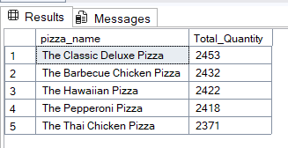
- BOTTOM 5 PIZZAS BY QUANTITY:
SELECT TOP 5 pizza_name, SUM(quantity) AS Total_Quantity
FROM [pizza_sales (1)]
GROUP BY pizza_name
ORDER BY Total_Quantity ASC
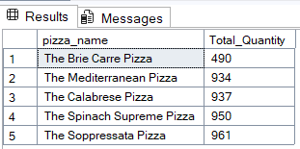

- TOP 5 PIZZAS BY TOTAL ORDERS:
SELECT TOP 5 pizza_name, COUNT(DISTINCT order_id) AS Total_Orders
FROM [pizza_sales (1)]
GROUP BY pizza_name
ORDER BY Total_Orders DESC
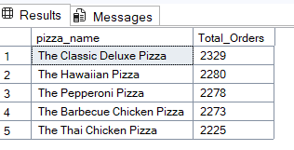
- BOTTOM 5 PIZZAS BY TOTAL ORDERS:
SELECT TOP 5 pizza_name, COUNT(DISTINCT order_id) AS Total_Orders FROM [pizza_sales (1)]
GROUP BY pizza_name
ORDER BY Total_Orders ASC
